Crash Test of Rockets (SOLUTION)

Or: Analysis of Motion and Energy Absorption Crumple Zones

Using Filtering and Simple Algorithms

(rev 3)

**Introduction**

An air-rocket is a toy rocket launched with an impulse of air. The company that hired you, Toy Rocket Inc., prefers to design the air-rocket to be as safe as possible. One safety precaution is to design the rocket tip in such a fashion, that if the rocket hits a person, the peak force that is imparted to the person is as small as possible. The rocket tip should deform and absorb the rocket energy, similar to the crumple zone of an automobile. A video system is used to characterize different rocket tips.

Consider two rockets of the same mass, and impact velocity. During impact, a ‘safe’ rocket will impart a small force over a longer period of time. An ‘unsafe’ rocket will have a very narrow and high force versus time curve. The energy/momentum absorbed will be the same for both rockets. This is analogous to the use of crumple zones in automobiles. The more that energy dissipates into the vehicle, the less chance a passenger is hurt.

You have been supplied with 5 different air rockets with different tips or construction and an air bladder launch mechanisms. The 5 types of rockets are:

1. Light-Long Rubber Tip Rocket
2. Light-Short Rubber Tip Rocket
3. Dense Rubber Tip Rocket
4. All Plastic Tip Rocket
5. Propeller Tip Rocket

**Discussion**

Accurately measuring high-speed, localized, impulsive forces is difficult with force plates, accelerometers, or any other type of direct contact measurement device. It is challenging to attach such sensors. In addition, the fast, impulsive, nature of the forces can makes it a challenge to remove the dynamics of the sensors from the measurements.

Alternatively, if position or velocity can be measured in a non-contact fashion, simple calculus tells us how to calculate acceleration. Simple dynamics theory then tells us how to determine forces.

The non-contact measurement system used for the air-rocket impact tests is a video-based system. Specifically, it is a calibrated, high-speed, video based, motion capture system. From calibrated video sequence, one can easily determine the position of a rocket as a function of time.

The launched rocket crashes into a stationary plate. The rocket hits the plate and rebounds. During the impact, during the time that the rocket is in contact with the plate, forces change the magnitude and direction of the rocket's momentum. Different tips have different momentum absorption characteristics.

We compare different tips, specifically their momentum absorption characteristics and impact forces, by launching rockets with these different tips at a stationary object (with mass and impact velocity held constant). The rate at which the rockets slow down and rebound will reveal each tip’s momentum absorption characteristics and allow us to calculate the forces that are imparted to the impacted object.

The specific metrics of interest are the peak force and the average force. By comparing the peak and average forces for similar rockets with different 'tips', we will compare the material and designs for various rocket tips.

**Background Theory**

Notation

x - position

F - force

m - mass

v - velocity

p - momentum

a - acceleration

t - time

We directly measure the position of a rocket versus time, x(t). From position we calculate velocity. Once the full velocity profile of a rocket is known, which includes its velocity before, during, and after impact all of the relevant accelerations and forces are calculated.

The velocity and acceleration can be determined from the following well-known relationships.

 *Equation 1*

 *Equation 2*

These relationships indicate that velocity is the time rate of change of position, and that acceleration is the time rate of change of velocity.

We are interested in the forces on the rocket during impact. Newton's Law for a rigid body is written as follows.

 *Equation 3*

The force on an object is equal to the rate of change of an object's momentum, the product of mass and velocity.

The maximum instantaneous force is determined:

 *Equation 4*

Where amax is the maximum acceleration. This is when the rocket's momentum and velocity vectors change direction (qualitatively from up to down).

Newton's equation (eq 3) is manipulated into the following form;

 *Equation 5*

From further manipulation we determine the average force during impact once we know the velocity profile.

 *Equation 6*

This indicates that if we know the velocity just before impact, v2; the velocity just after impact, v1; and the total time of impact (t2-t1), then we can approximate the average force during impact.

**Experiment**

We are concerned with determining the force profile and most importantly the peak force imparted to a stationary object. A test fixture was designed and built to launch air-rockets into a solid plate. The test fixture consists of a launch mechanism oriented perpendicular to a metal plate about 12 inches away from the tip of the rocket.

The measurement system for the test rig is a video-based system. Specifically, it is a calibrated, high-speed, video based, motion capture system. From calibrated video, we determine the position as a function of time for the rocket. Once we know the position, we can easily determine velocity and acceleration. We fundamentally want to determine the force profile as a function of time, especially the peak force. The forces can be calculated directly from measurements of velocity and acceleration as discussed in the theory section.

The air-rocket is placed on a hollow cylinder (the launch pad) that is connected to an air bladder. A person drops a known weight from a known height to deliver a consistent impulse on the bladder and force air through a hose, through the hollow cylinder, which delivers an impulse of air to the rocket. The rocket is thus launched.

The camera is oriented perpendicular to the rocket flight path. This geometry is depicted below.

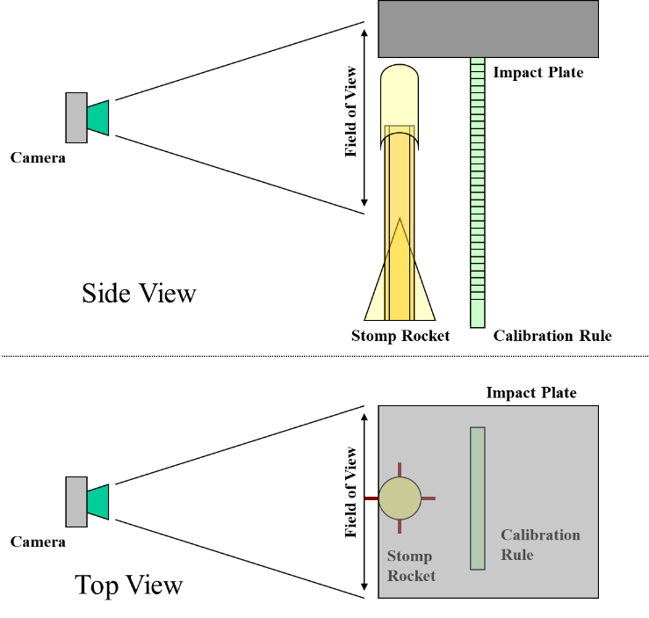

*Experimental Setup for capturing with high-speed video cameras the*

*motion of the impact rockets*

The camera's scene is calibrated so that we know the relationship between pixels from the camera and real physical dimensions. Targets (high contrast markers) are placed on the rocket in several places. The rocket launch and high-speed video recording is synchronized so that that we capture a video sequence that starts from a time before impact and ends after the rocket has impacted and then rebounded

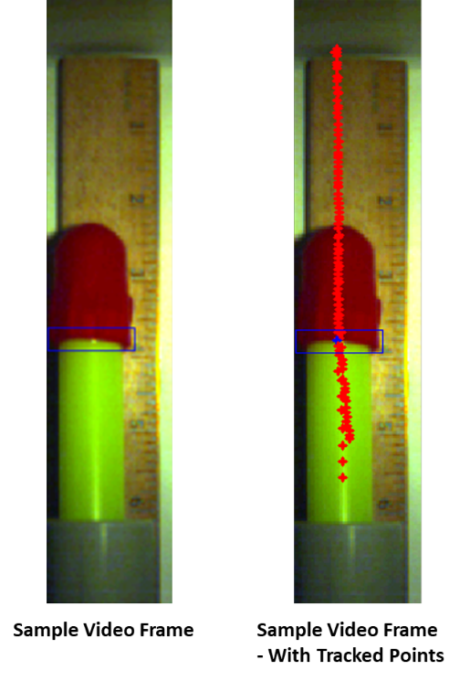

*Sample Frames from Videos of Impact*

Once we have a high-speed video sequence of the rocket. Special tracking algorithms track the markers or other highly distinct features through the entire sequence. The tracking algorithms output the two-dimensional position versus time curve for the rocket, **x**(t).

Two sets of measurements were performed on a series of 5 rockets. The two tests were a 15.5 meter/sec test and a 28.4 meter/sec test. The motivation for the two sets of tests is that it was found that the rockets had qualitatively different force versus time characteristics depending on the initial velocity of the rocket before impact. The following photographs show the different rocket styles and the labels attached to each style for this report:

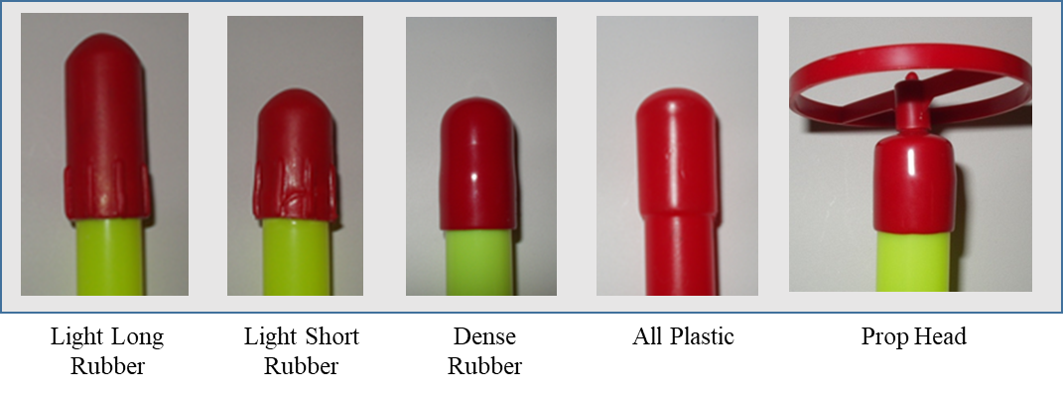

Project Description

Included with this project are 10 data traces that correspond to the linear position of the rocket versus time. There is one data trace for each of a low and high-speed launch for each of 5 rockets.

Plotted below are representative raw tracking data. The majority of the noise in the position signal is “pixel jitter”. “Pixel jitter” is an artifact of the feature-tracking algorithm used to calculate the position of a template in a single frame; the algorithm is accurate to 1 pixel.



Plotted below are representative un-filtered “velocity” and “acceleration” traces. The need for filtering is apparent.

**Goal:**

Determine which Rocket Tip is the safest.

Assuming all other variables (velocity of rocket before impact, mass of rocket, etc.) are equal, we define the safest to be the tip that imparts the lowest average force and/or peak force when impacting a object.

Concisely, the two things that you are to determine are:

* The Peak Force imparted by the rocket during impact for each tip.
* The Average Force imparted by the rocket during impact for each tip.

There are two subtasks associated with this Goal.

*1) Filtering -- Calculate the velocity and acceleration profiles from the position data for each rocket tip.*

2) *Determine the Total Time of Impact and Imparted Forces*

**Subtasks:**

*1) Filtering -- Calculate the velocity and acceleration profiles from the position data for each rocket tip.*

This requires that you filter, or smooth, the tracking data (position data) and to differentiate the position data to determine velocity and acceleration. You are free to design any filters you see fit. We suggest an iterative approach, refining in stages. We suggest plotting the unfiltered data and un-filtered results on top of one another so that you may see the results of the filtering operations.

Your filters should not distort the general shape of the position or velocity signal.

One issue to consider is the order of filtering (smoothing) and differentiation. Do you filter the position data and then differentiate? Or vice-versa? Does it make any difference in the end? Does it make any difference in the iterative process of designing the filters?

In your report please be sure to include:

* The smoothed position data
* The frequency responses of your data (before and after filtering)
* Calculated velocity and acceleration traces.

Original and Filtered Position, Velocity, and Acceleration





Frequency Spectrum of Velocity before and after filtering of position data





2) *Determine the Total Time of Impact and Imparted Forces*

One aspect of calculating the average force is to determine the Total Time of Impact, the time interval from initial contact to final breaking of contact at the commencement of the rebound. The Total Time of Impact can be determined by analyzing the velocity profile or the acceleration profile. We suggest designing an algorithm that takes as input a velocity or acceleration profile and returns as output the Total Time of Impact.

With the algorithm to determine the Total Time of Impact, calculate the peak (from Equation 4) and average force (from Equation 6).

If you are uncertain about your results in the Filtering subtask, you can use our solution to Subtask 1. Shown below are 6 of the 30 pre-filtered results:





There is variability in the starting velocity of the rocket, in order to compare the results across rocket launches; you should normalize (divide) the Peak Force and Average Force by the (approximately constant) velocity before impact.



Force during Impact Normalized to Pre-Impact Velocity (kg/sec)